**Date:** 26.04.2019

**Attendees:** Furkan Karakaya

**Location:** Electrical Machines Laboratory

**Target:** V1.3 Gate Driver Board (#1)

**Test type:** Inverter test with RL load

**Aims before the test:**

**1.** To obtain current waveforms with Rogowski Coil

**Conditions:** 22 Ohm Ron, 2 Ohm Roff. 0-300V VDC. RL Load: Five different stages. 10kHz-40kHz fsw. 0.9 power factor. Sinusoidal PWM with 0.9 modulation index.

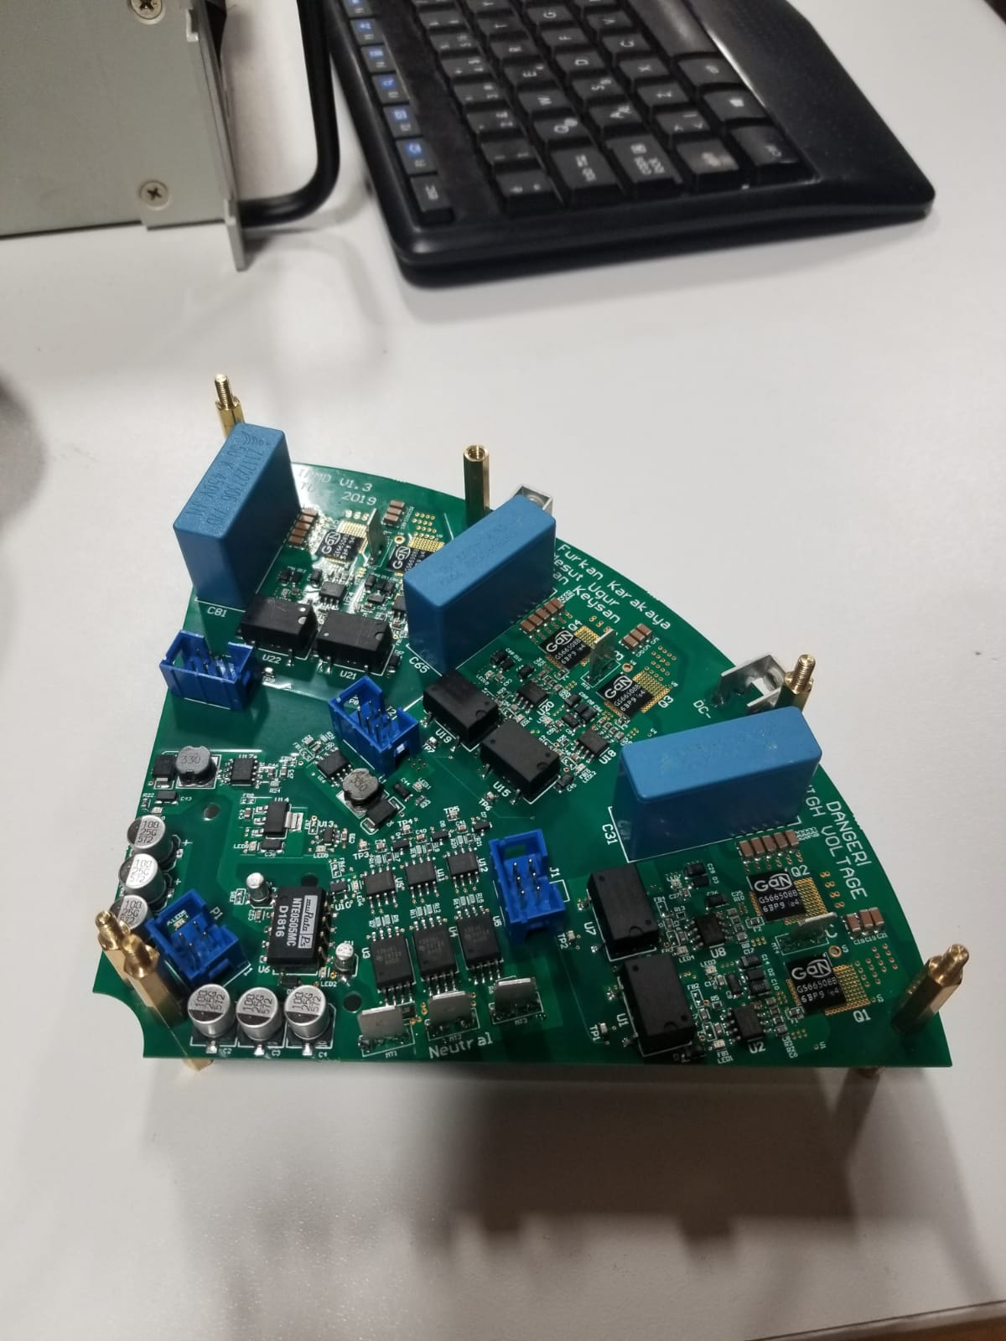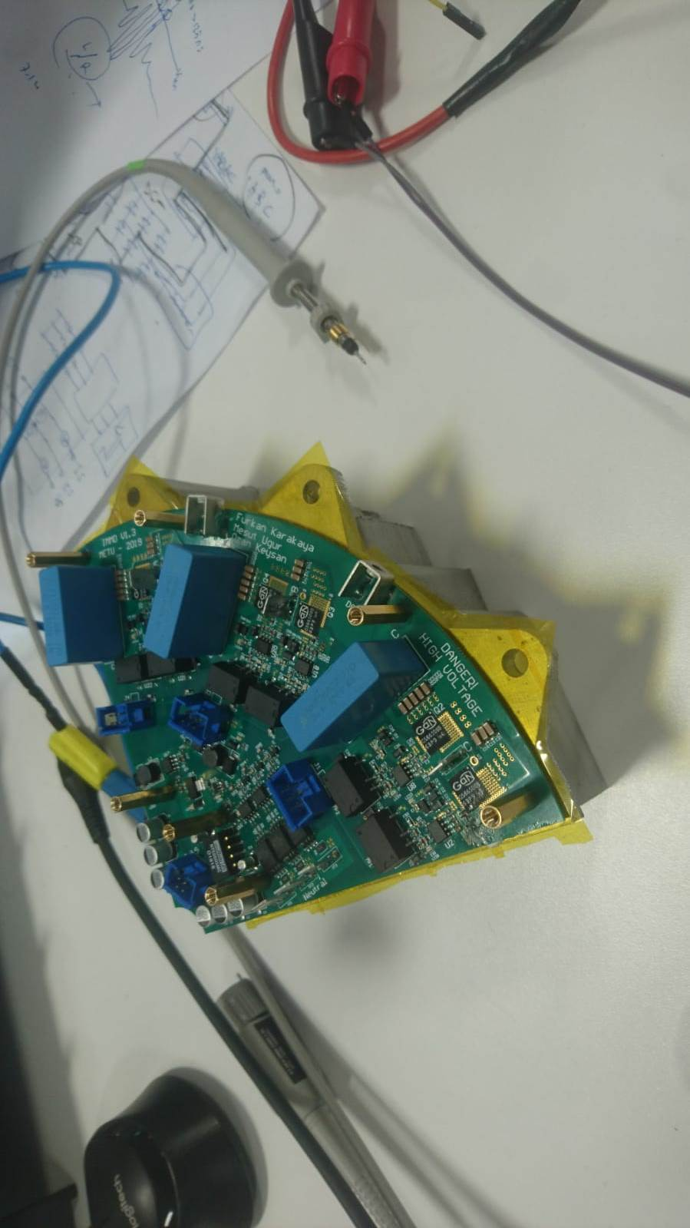

**Steps:**

1. The phase current is measured with rogowski coil and current probe.
2. The rogowski results are compared with simulation.

**Results:**

1. 40 kHz switching frequency without any filtering in oscilloscope



1. 10 kHz switching frequency without any filtering in oscilloscope



